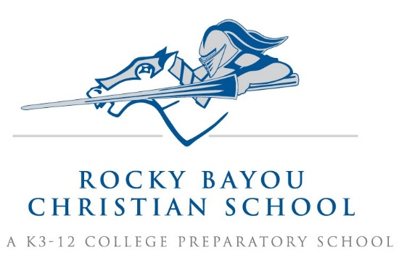

Crestview 1st Grade Supply List AY26/27

- 3 pkgs. 24 ct. Crayola crayons
- 1 pallette Crayola water colors, 8 count
- 1 pkg Crayola Twistables colored pencils 12 pk.
- Play-doh, 2 pack
- 2 pkgs Black Fine Tip Expo Markers (1 for music, 1 for classroom)
- 2 large canisters of Disinfectant wipes (Clorox wipes)
- 2 box Kleenex- large
- 3 plastic folders with pockets: purple, blue, and yellow
- 1 box plastic spoons
- 1 roll paper towels
- 1 box Dixie cups (medium size – 7oz, clear plastic)
- 1 pair headphones (to be kept at school)
- 2 fine tip Sharpie Markers (Art)

- Girls only- 1 pkg red ink pens
1 box Ziploc bags/gallon size

- Boys only- 1 pkg black ink pens
1 box Ziploc bags/sandwich size

Please put your child’s name on ALL coats and sweaters.

