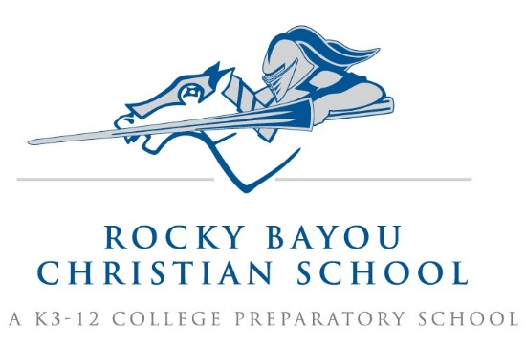

Crestview 2nd Grade Supply List AY25/26

- 1 plastic pencil box
- 1 box of 12 colored pencils, optional (must fit inside plastic pencil box)
- 2 boxes, 24 pack, Crayola crayons (1 for art, 1 for classroom)
- 1 pair Fiskars scissors
- 4 plastic folders, with pockets, 1 of EACH of these colors: yellow, blue, purple, and green
- 2 soft pink rectangular erasers
- 2 pkg. Black Expo Markers, Fine Tip
- 2 boxes Kleenex- large
- 1 box spoons
- 1 pkg glue sticks, 3 count
- 1 roll paper towels
- 1 pkg paper plates (not Styrofoam)
- 1 pair headphones, over the ear style works best (to be kept at school, and labeled) This can be re-used from last year, if desired.
- Do not send any pencils, they will be provided for the class

Boys Only:
- 1 marble composition -no spiral- notebook

Girls Only:
- 1 1” binder – any color

*Do not send white Elmer’s glue (bottled) or scotch tape.
*Using a sharpie, write your child’s FIRST name in upper right corner of the folder.
Please put your child’s name on ALL coats and sweaters.

Campus in Niceville & Crestview – 850-797-7227 – www.RBCS.org

Campus in Niceville & Crestview – 850-797-7227 – www.RBCS.org

Campus in Niceville & Crestview – 850-797-7227 – www.RBCS.org

Campus in Niceville & Crestview – 850-797-7227 – www.RBCS.org

