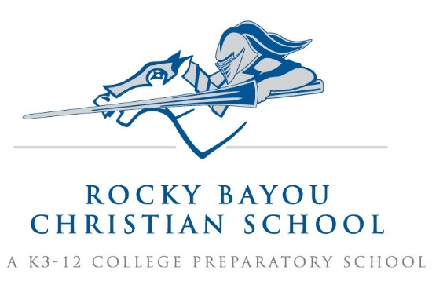

Crestview 3rd Grade Supply List AY25/26

- 1 plastic pencil box (large enough for colored and regular pencils to fit)
- 1 marble composition notebook
- 2 pkgs of 2-4 dry erase markers, EXPO brand, fine point only, black only
- 1 pkg wide ruled notebook paper
- 1 box colored pencils
- 2 pkgs Ticonderoga #2 pencils (24 count)
- 1 pair Fiskar scissors
- 1 pkg soft pink rectangular erasers (3 pack)
- 2 boxes Kleenex- large
- 1 pkg skinny high lighters- multi-colored
- 1 each of the following colors of three-pronged, plastic folders with pockets: orange, purple, red, green, black, and blue- DO NOT PUT NAMES ON FOLDERS
- 1 large roll paper towels
- 1 pkg forks
- 1 pair of headphones (to be kept at school)
- 1 pkg cheap paper plates (not Styrofoam)
- 2 boxes Crayola Watercolors (16 pack) (art)

- Girls only- 2 small glue sticks
- Boys only- 1 pkg red ink pens

Please put your child’s name on ALL coats and sweaters.

