Rocky Bayou Christian School

Athletic Parents Manual 2025-2026

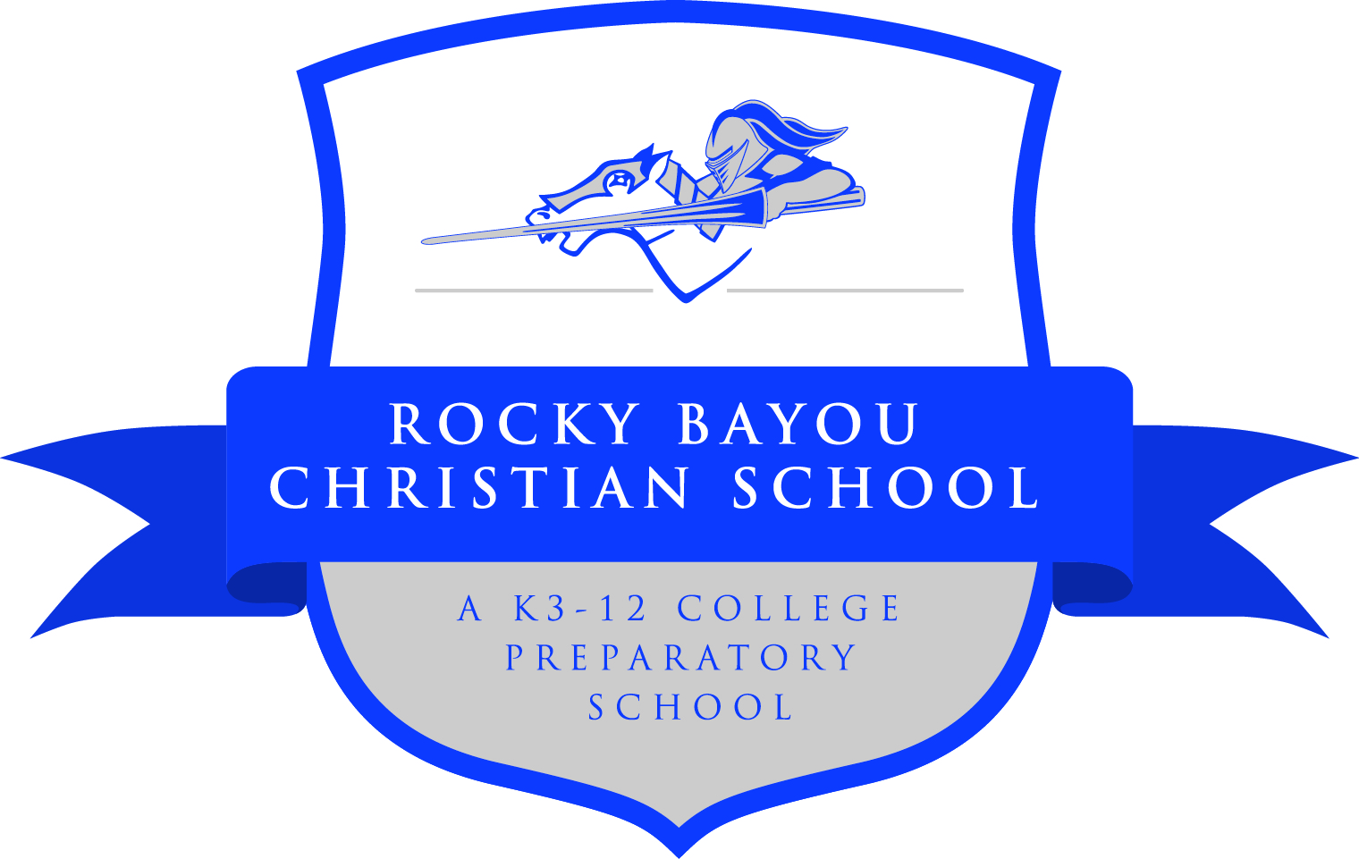

WWW.RBCS.ORG
2101 N. Partin Drive
Niceville, FL 32578

Contents
Athletic Opportunities: 5
1.0 Organization of Athletic Department 6
1.1 Athletic Department Requirements 6
1.2 Coaches Guidelines 6
1.3 Athletics Boosters 7
2.0 Rules for Participation 7
2.1 Supervision 7
2.2 Eligibility 7
2.2.1 Eligibility Forms 7
2.2.2 Academic Standing 7
2.2.3 Residence and Transfers 8
2.2.4 Transfer 8
2.2.5 Eligibility Limitations 8
2.2.6 Limit of Eligibility 8
2.2.7 Conduct and Discipline 8
2.2.8 Attendance 8
2.2.9 Home School Students 8
2.3 Recruiting 9
3.0 Season Guidelines 9
3.1 Season Guidelines 9
3.1.1 Off-Season 9
3.1.2 In-Season 9
3.1.3 Summer 9
3.2 In-Season Sports Guidelines 10
3.2.1 Attendance 10
3.2.2 Roster Policy 10
3.2.3 Playing Time 10
3.2.4 Playing Up 11
3.2.5 Overlapping Sports Seasons Policy 11
3.2.6 Multiple Sports in Same Season Policy 12
3.2.7 Grade Probation Policy 12
3.2.8 Co-Curricular Conflicts 13
4.0 Procedures 13
4.1 Registration 13
4.1.1 Athletic Fees 13
4.1.2 Eligibility Forms 14
4.2 Injuries and Accident Reports 14
4.3 Dress Code 14
4.4 Uniform Policy 14
5.0 Conduct 15
5.1 Commitment to Team 15
5.2 Sportsmanship and Respect for Others 15
5.3 Playing Time 16
5.4 Parent Involvement 16
5.5 Communication 16
5.6 Athlete Discipline 17
6.0 Lettering and Awards 18
6.1 Team Awards 18
6.2 Lettering 18
6.2.1 Baseball/Softball 18
6.2.2 Basketball 18
6.2.3 Cross-Country 18
6.2.4 Football 19
6.2.5 Golf 19
6.2.6 Soccer 19
6.2.7 Swim 19
6.2.8 Track and Field 19
6.2.9 Tennis 20
6.2.11 Volleyball 20
6.2.12 Weightlifting 20
6.2.13 Wrestling 20

RBCS Vision Statement

To impact the world by equipping each generation to use their God-given abilities as champions for Christ

RBCS Mission Statement

Our mission is to assist parents in their God-given responsibility to train and develop in their children a biblical worldview, Christian character, and the skills necessary to fulfill God’s calling in their lives.

Athletic Department Vision Statement

Through our commitment to excellence in Christian education, Rocky Bayou Christian School endeavors to educate our athletes in an environment that encourages and expects the highest level of achievement academically, spiritually, athletically, and personally.

Athletic Department Philosophy

The philosophy of the Rocky Bayou Christian School Athletic Program is based on the belief that participation in athletics, both as a player and as a spectator, is supportive of the school’s overall mission. It provides the opportunity for students with athletic talent to develop to a higher level of performance, proficiency, and physical fitness. Each athlete is taught to play to the best of his/ her ability for the benefit of the team. Emphasis is placed on healthy competition, team sportsmanship, unity, discipline, and respect for self and others. Participation, however, is a privilege, not a right, which carries with it responsibilities to the school, the team, and the larger community.

Rocky Bayou Christian School does not discriminate on the basis of race, color, national, or ethnic origin in the administration of any of its policies or programs.

Definitions

FHSAA: Florida High School Athletic Association – the governing body for high school sports with which Rocky Bayou Christian School participates during the school year. All coaches must understand and abide by the rules and regulations comprised in the FHSAA bylaws and policies handbook. It is the responsibility of each head coach to educate his assistants, players, parents, boosters, and volunteers of the responsibilities required of them regarding eligibility, participation, sportsmanship, and recruiting as laid out in the FHSAA handbook.

Athletic Opportunities:
Rocky Bayou Christian School currently offers athletic participation in the following FHSAA sanctioned Varsity sports:
- Boys/Girls Cross Country
- Boys/Girls Golf
- Boys Football
- Girls Cheerleading
- Girls Volleyball
- Boys/Girls Swimming
- Boys/Girls Soccer
- Boys/Girls Basketball
- Boys Wrestling
- Girls Fast Pitch Softball
- Boys Baseball
- Boys/Girls Track and Field
- Boys Weightlifting
- Boys/Girls Tennis

Rocky Bayou Christian School currently offers Middle School (grades 6-8) athletic participation in the following sports:

- Boys Football
- Boys/Girls Cross-Country
- Girls Cheerleading
- Boys/Girls Golf
- Girls Volleyball
- Boy’s/Girls’ Soccer
- Boy’s/Girls’ Basketball
- Boys Wrestling
- Girls’ Fast-Pitch Softball
- Boys’ Baseball
- Boys/Girls Swimming
- Boys/Girls Track and Field
- Boys/Girls Tennis
- Boys Weightlifting

.

1.0 Organization of Athletic Department

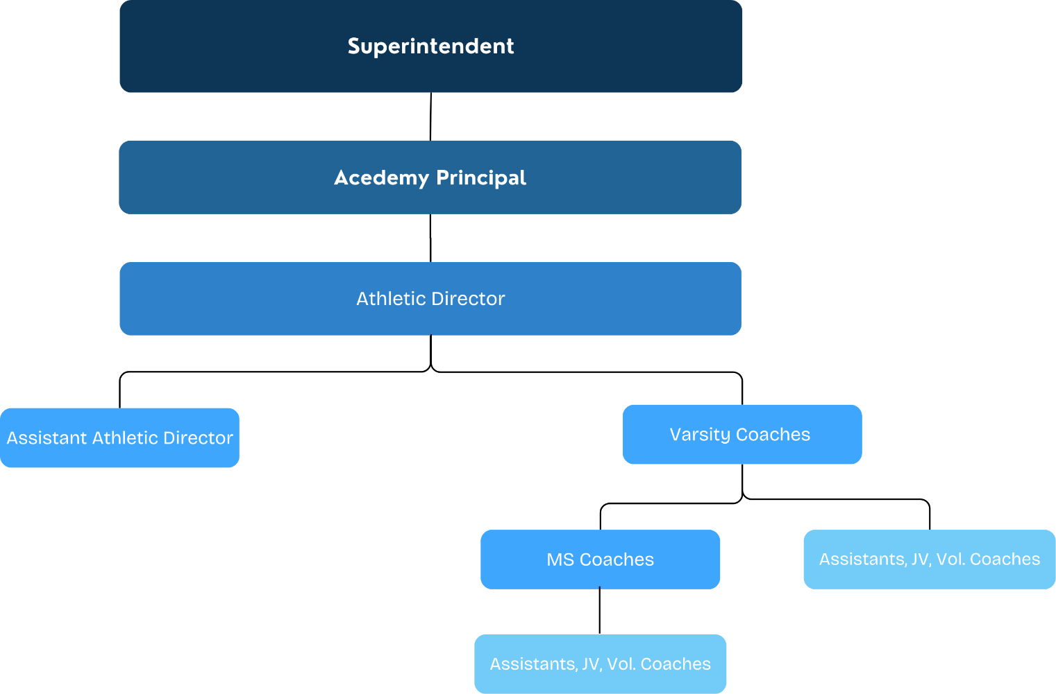

1.1 Athletic Department Requirements
- Know the rules and regulations of the handbook of the FHSAA, especially pertaining to your sport and player eligibility.
- Budget – the Athletic Director will set the annual budget and oversee the spending of those funds.Handles all Registration of Athletes for sports in their appropriate seasons.
- Ensure all eligibility forms and fees are turned in.
- Maintain communication with the Guidance office for student academic eligibility.
- Sets and ensures procedures for day-to-day operations for coaches, teams, and athletic department as a whole.

1.2 Coaches Guidelines
- Coaches must demonstrate Christian leadership, coaching ability, and teamwork within the Athletic Department.
- Know the rules and regulations of the handbook of the FHSAA, especially pertaining to your sport, player eligibility, and recruiting.
- All coaching staff, including volunteer coaches, must provide fingerprints and pass a background check and drug test.
- Setting a volunteer list for running tickets booth, concessions (if applicable), and spirit wear tables at all games.
- Each coach is responsible for keeping their area of play/practice clean and organized. Attend all district meetings for your sport
- Complete all mandatory NFHS courses
- Attend all All-Star selection meetings for your sport
- Coaches must be present at all times during practice and games.
- Adhere to guidelines for student eligibility
  - FHSAA eligibility forms
  - Athletic Fees
  - Registration
- Adhere to procedures set forth by Athletic Director for day-to-day operations
- Coaches must ensure enforcement of the daily attendance rule – Students must be in school for half a day to be eligible to practice or play that day.
- Transportation – Head coaches will coordinate transportation for each athletic events/activities
- Coaches are responsible for scheduling games and communicating that schedule with Athletics and School in timely manner.
- Schedule use of facilities with AD and report in writing any problems with facilities that need attention.
- Lettering System – Explain to your team before the season starts. (See Lettering Criteria)
- Athletic Awards Criteria should be posted and/or provided to athletes and parents by head coach.

1.3 Athletics Boosters
The Athletics Boosters (Athletic Support Team – A-Team) is an integral component of the Athletic Department. The mission of the A-Team is to contribute to the Athletic Program in such a way that our athletes and coaches will have the opportunity to achieve to their greatest potential. To help kindle and build school spirit, school pride, and the enthusiasm to support current and future Knights athletes participating in all the athletic teams Rocky Bayou Christian School currently offers and those that will be offered in the future. They will fulfill this mission by working with the AD, and coaches, to acquire sponsorships and help run special events.
For further information see Athletic Support Team Constitution and By-Laws.

2.0 Rules for Participation

2.1 Supervision
The safety and well-being of our athletes is paramount. A member of Rocky Bayou Christian School’s Athletic Department must attend all times during practices and games.

2.2 Eligibility
The following are important areas of concerns regarding FHSAA athletic eligibility:

2.2.1 Eligibility Forms
All athletes must have up-to-date forms on file with the Athletics Department prior to participation.

2.2.2 Academic Standing
RBCS will follow all FHSAA guidelines for Academic and Student Eligibility. For detailed information on these areas please refer to the FHSAA Handbook.
In general:
- Students must maintain a minimum of 2.0 (on a 4.0 scale) GPA to be eligible for participation in a sport.
  - This GPA is checked at the end of each semester for eligibility for FHSAA participation.
  - Students falling below this will be ineligible for at least one semester (the upcoming semester). If the GPA rises above this criterion, then at the beginning of the next semester a student may return to an eligible status.
- RBCS will perform weekly grade checks sending out a weekly Grade Probation list at the beginning of the week, at the discretion of the Principal.
  - Students who have a F or two D’s will be placed on Grade Probation.
  - For further details on the RBCS Grade Probation Policy please refer to the designated section.

2.2.3 Residence and Transfers
(From FHSAA Manual)
A student will be eligible in the first school he/she enrolls in each school year, or at the school where he/she participates in an athletic practice prior to the beginning of the school year. The student will be eligible in that school as long as he/she remains enrolled in that school regardless of where he/she lives, with whom he/she lives or at which school he/she attended last year.

2.2.4 Transfer
(From FHSAA Manual)
If a student transfers from attendance at one school to attendance at another school during a school year, they may seek to immediately join an existing team if the roster for the specific extra-curricular activity has not reached the activities identified maximum size, provided the coach for the activity determines that the student is has the skill and ability to participate. The student may not be declared ineligible because the student did not have the opportunity to comply with qualifying requirements.

2.2.5 Eligibility Limitations
(From FHSAA Manual)
Student will be ineligible for participation in sports if he/she turns 19 years of age before July 1st.

2.2.6 Limit of Eligibility
(FHSAA Manual)
Once a student is declared as a 9th grader, regardless of successful completion of the ninth grade, the student has a running clock of four consecutive years to compete in FHSAA Scholastic sports.

2.2.7 Conduct and Discipline

2.2.7.1 Detentions
If a student is assigned a detention the day of an athletic competition, he must serve his detention.
It will be up to the coaches discretion whether or not playing time in a contest/game will be affected.
Students are required to still attend practices after a detention is served.

2.2.7.2 Out of School Suspension (OSS)
Students serving an OSS will not be permitted to participate in any contest/game during the extent of the suspension.

2.2.8 Attendance
Athletes are to be in attendance in class for half a day to be eligible to participate in athletic practice or contests scheduled for that day.
Students that are absent from school may not attend practices or games. Exceptions are made for qualified medical appointments (note from the doctor/dentist), school trips, or funerals.

2.2.9 Home School Students
Any home school student that wishes to participate at RBCS must be directed to the Home School Coordinator for proper student application and registration. Home school student athletes are eligible to participate in RBCS athletics pending their approval and qualifying to be an RBCS Homeschooler.
Homeschool, or Non-Traditional, Students must fill out and EL7 to be able to participate in Athletics.

2.3 Recruiting
The FHSAA policy regarding undue influence is “POLICY 36” found in the FHSAA handbook. Athletic recruiting is a gross violation of the spirit and philosophy of educational athletics. Athletic recruiting is unethical and unsporting conduct and is forbidden by FHSAA By-Laws.
RBCS will abide by all rules regarding Policy 36.

3.0 Season Guidelines

3.1 Season Guidelines
RBCS will follow all rules and policies outlined in the FHSAA Handbook

3.1.1 Off-Season
Off-Season is the time considered during the school year when the season is not officially in session according to the FHSAA calendar.
- Only bona-fide students of RBCS, either traditional or non-traditional, may participate in off-season/pre-season conditioning sessions or open gym/facilities sessions.

3.1.2 In-Season
In-Season is the time of the official season for a sport as designated by the FHSAA.
Summer is the time from the last day of school of one school year to first day of school for the following school year.

3.1.3 Summer
Summer workouts are non-Mandatory, and a student cannot be withheld from being part of a team because they did not attend Summer Workouts.
- Football is the only sport in the FHSAA that is strictly controlled as to when athletes can wear equipment and participate in physical contact. RBCS will follow all policies and scheduling set forth by the FHSAA regarding this.

- While RBCS believes in excellence in our performances we do at the same time maintain a committed perspective to biblical role of the family. During summer session we encourage our young people to go on family vacations, do youth camps, participate in missions, get a job to begin earning money. We affirm that most scholastic athletes (not just RBCS students) will not become a professional in sport. However, they will become a professional in life. They will become professional in earning money to sustain and provide for their family. They will become professional in being a citizen in their future communities. They will become professional in being spouses and parents.

- With that in mind, we fully support our athletes being part of other ventures during the summer. However, we do ask that parents, and students, to remember that being part of sports is also an avenue of their development, not for a sports profession, but in life. Lessons learned in the sport can tremendously help a student become a better person and therefore adult, mom, dad, worker, owner, etc.

- The follow up to that request is that students be at summer workouts when assigned when they are in town. We do not want athletes sitting at home when they could be at workouts bettering themselves and others.

3.2 In-Season Sports Guidelines
RBCS will follow all FHSAA guidelines for In-Season conduct and scheduling.

3.2.1 Attendance
All Practices and Games are mandatory and any absence or tardy may be disciplined accordingly.
- Players are to communicate with the Head Coach for any absences or tardiness prior to the practice or game in a timely and appropriate manner.

3.2.2 Roster Policy
Roster size is to be highly considered when formulating a team. All teams on the varsity level have strict guidelines according to the FHSAA handbook. Each team is allowed a maximum specific number per sport that may enter the State Series (Districts and beyond). RBCS will adopt the same limitations for all teams (middle school, junior varsity, high school).
Only bona fide students of RBCS, either traditional or non-traditional, may be part of the team’s roster.
- Baseball – 22
- Basketball – 15
- Cross-Country – 15
- Football – 60
- Golf – 10
- Soccer – 25
- Softball – 22
- Swimming – 60
- Tennis – 12
- Track & Field – 80
- Volleyball – 15
- Weightlifting – 3 per weight class
- Wrestling – 40
*These numbers are for each gender in each class (e.g., 15 varsity basketball boys, 15 JV basketball boys, and 15 middle school basketball boys).

3.2.2.1 Tryouts
Teams conducting a tryout are to make ensure adequate announcements are made to the student body of both traditional and non-traditional students and to their parents. The time, date, and location of the tryout are to be well communicated in written and verbal formats.
- ONLY bona fide students are allowed to tryout or participate on a team. If a student has not been confirmed as either an official traditional or non-traditional a student cannot participate in any capacity.
- Tryouts may not take place before the first allowable practice date set forth by the FHSAA
- The final cut-list is to be communicated to students and to parents effectively and immediately.
  - The cut-list is to be communicated on the next business day.

3.2.3 Playing Time
Playing time is at the head coach’s discretion and is non-negotiable.
Determination of playing time is based on several factors, being solely determined by the coaching staff, such as (but not limited too):
- Performance and skill in both practice and in games
- Attendance to practice and workouts
- Tactical needs in a game
- Fitness
- Work ethic
- Attitude

3.2.4 Playing Up
Athletes in the high school grades (9-12) who are playing on a JV team may be moved up to the Varsity team at the discretion of the Head Varsity Coach at any time. Though, no violation of FHSAA policies regarding athletes playing JV and Varsity may occur. Head Varsity coaches may require any JV player to move up to Varsity, but no violation of the roster policy may occur.

Athletes in 6th -8th grade may move up to the JV or Varsity level at the approval of the Head Coach, Athletic Director, and parents.

All middle school athletes participating in team sports (football, volleyball, basketball, soccer, baseball, and softball) must play their middle school sports season to be considered to move up to a JV or Varsity level.

Students in the 5th grade, or below, are not allowed to play middle school sports.

3.2.5 Overlapping Sports Seasons Policy

It is the desire of the RBCS Athletic Department to afford all its student’s opportunities to express themselves in their athletic gifting’s. It is not the desire of the Athletic Department to diminish the abilities, or capabilities, of the physical talent of any student, but rather to allow them to flourish and be displayed. The goal for the Athletic Department is to allow, and foster, all students to grow to reach their fullest potential and achieve as much as they possibly can.
At the same time, it is the desire of the RBCS Athletic Department to protect the integrity, character, and unity of every team and student. To cause damage or harm to either of those would be a disservice to the goals and vision of RBCS, its sports teams, and the students.
Students are expected to finish their season of the sport they began before beginning another sport in another season.

Students who start one season and then quit (own choice not due to injury or extenuating circumstances) must wait until that sports season is over before beginning in a sport in another season.
Athletes in a current season must be allowed to tryout for the upcoming sport. The upcoming season coach must make accommodations for the current season athlete to tryout.
Students may be allowed to participate in upcoming (overlapping) sports season under the following criteria:
The head coach of the current season approves and agrees to the following conditions.
- No practices of the current seasons will be interrupted for an athlete to attend a practice/workout/training session of an overlapping (upcoming) sport.
- Only for a game of an overlapping (upcoming) sport could there be an interruption of a practice for a current season sport.
- A game for a current season sport cannot be interrupted for an overlapping (upcoming) season sports game.
It is to be understood that though there can be an approval for an athlete to compete in a current season sport and an overlapping (upcoming) season sport, it not the preferred model. The preferred model is for each athlete to complete his/her season before beginning the next season. The main goal is integrity of the individuals and teams.

3.2.6 Multiple Sports in Same Season Policy
It is the desire of the RBCS Athletic Department to afford all of its students the opportunities to express themselves in all of their athletic gifting’s. It is not the desire of the Athletic Department to squash or diminish the abilities, or capabilities, of the physical talent of any student, but to allow them to flourish and be displayed. The goal for the Athletic Department is allow, and foster, all students to grow and reach their fullest potential and achieve as much as they possibly can.
At the same time, it is the desire of the RBCS Athletic Department to protect the integrity, character, and unity of every team and student. To cause damage or harm to any of those aspects of any team or student would be a disservice to the goals and vision of the Athletic Department, RBCS, its sports teams, and the student.
Student are permitted to participate in more than one sport in the same season based on the following criteria and approval process.
- The student must bring the request to participate in multiple sports to the attention of the coaches of the sports involved.
  - The request must be made at the latest, one full week before the FHSAA start date of whichever sport starts first on the calendar.
- Then the student must bring the request to the Athletic Director
  - The request must be made at the latest, one full week before the FHSAA start date of whichever sport starts first on the calendar.
- The Athletic Director and all involved head coaches must agree in unanimity based on the following:
  - He/she must have demonstrated skills and abilities to make him/her an impact player/participant on all teams involved.
  - Demonstrated to have the ability to handle and maintain multiple practice schedules and games schedules.
  - Demonstrated the ability to clearly communicate with coaches
  - Must be a student in good standing with the FHSAA
  - Must be in good academic standing with RBCS
  - Must have a good discipline record with RBCS
  - Their participation in multiple sports in one must not cause a negative impact on any team involved, but rather a positive impact and helping the teams involved to achieve.

3.2.7 Grade Probation Policy
Students must maintain an acceptable grade point average with the FHSAA per school semester of an overall (cumulative) 2.0 GPA.
These GPAs are checked at the change of every semester for the upcoming semester’s eligibility.
RBCS does a weekly check for the Academy students. Students who have either 2 D’s or 1 F on the weekly check are deemed ineligible.
Students who are deemed ineligible can get off the probation quickly.
- They must talk to the Principal and the teacher(s) with whom they have an inadequate grade.
- Whatever work that is allowed to be made up, redone, or turned in late, needs to be done as soon as possible.
- As soon as the teacher(s) update the assignments the student may be off grade probation, pending the updated assignment’s grade brought the overall grade up to an acceptable level.
- Either the Principal, Vice/Asst. Principal, or guidance counselor will communicate to the AD or the head coach that the student is off GP.
While a student is on grade probation:
- They are not allowed to travel with the team, be on the sideline, or be part of the team in any official team capacity on game day.

3.2.8 Co-Curricular Conflicts
It is the responsibility of the student, and his/her parents, before registering for a team to avoid any potential conflicts, on-going or acute or RBCS related or outside.
It is the desire of RBCS for the students to be as well rounded as possible and able to use as many of their talents to their fullest potential. However, no one person can do everything at the same time and maintain integrity.
Students who wish to participate in athletics and any other event (fine arts play, concert, musical, travel ball, clubs, etc.) must receive approval from the Head Coach before tryouts or start date of practices.
If a student is approved to be part of an athletics team and another group, event, etc. then these rules must be followed:
- District contests and tournaments trump any other event
  - If an athlete cannot commit to fulfilling this athletic commitment, then the athlete cannot commit to the sports team.
- Any Post-Season competition trumps any other event
- A RBCS related special event (musical, concert, etc.) trumps any sports practice, if it was agreed upon before the season by the coach and athlete.
- An outside RBCS event can trump any RBCS sports practice, if it was agreed upon before the season by the coach and athlete.

4.0 Procedures

4.1 Registration
All athletes must register using the approved means and methods set by the RBCS Athletic Department.
This includes all FHSAA eligibility forms and athletic fees paid. Both parents and students must sign documents.

4.1.1 Athletic Fees
The athletic fee for any RBCS student, traditional or non-traditional, is $300. This fee will need to be paid before the first contest date. This fee is a one-time fee and will allow a student to participate in as many sports possible, according to the RBCS policies.

4.1.1.1 Refund Policy
Refunds will be determined based on the following situations/criteria.
100% Refund
If a student decides not to participate from time of registration up to the first contest date
If a student is “cut” (did not make the team) from a tryout.
0% Refund
If a student quits after the first contest date.
If a student is removed from the team by the coach, Athletic Director, or School Administration.

4.1.2 Eligibility Forms
Every athlete is required to have a physical examination form (EL2), emergency information form, and a parental consent form (EL3) on file in the Athletic Office before he/she will be allowed to try-out, practice, or participate in the Athletic Program at RBCS. Both, the EL2 and EL3, forms may be obtained through the school’s website, RBCS.ORG, the Athletic Office, or from the FHSAA.ORG website.

Non-traditional (homeschool) students must also fill out an EL7(v) form as well. This form is located on the RBCS website and the FHSAA website.

Under no circumstances may an athlete participate in a sport, whether a tryout, practice, or game, without ALL eligibility forms being turned in to and processed by the RBCS Athletics Department via the prescribed means.

A coach found in gross violation of this may be suspended or released from duties.

4.2 Injuries and Accident Reports
The Head Coach is responsible for assuring that a medical kit is available at every practice and game.

Athletes must report all injuries to a coach immediately. The coach is to administer appropriate first aid, if needed. The coach will make a decision whether an athlete should return to practice or contest, return to modified practice, or be transported to a hospital or doctor.

If the injury is serious enough to warrant modified practice, doctor, or a hospital visit, the parent/guardian must be notified immediately. If a student athlete is suspected of incurring a concussion parents must be notified immediately. Doctor or hospital referrals require doctor release to resume practice and participation.

An accident report must be filled out by the Coach should an injury occur at any time while a student is under his/her supervision.

The report is be turned in to the Athletic Office within 24 hours of the accident. Report forms may be found in Appendix A.

4.3 Dress Code
It is the responsibility of the Coaches to 1) adhere to the dress code, and 2) to enforce the dress code.
- All clothing to be worn by coaches and athletes at any RBCS Athletics (Games, Practice, Workouts, Fundraising Event) event shall be of appropriate fit.
  - Colors: Royal Blue, White, Black, Grey/Silver
  - Fit: modesty is the goal. Boys and girls should be dressed in appropriately fitting attire conducive to the sport.
  - All sports should require that any garment seen (under or over) is to be in RBCS colors.

4.4 Uniform Policy
RBCS will provide uniforms for all teams except teams that wear consumable uniforms. Uniforms are not to be worn by athletes during practices or workouts; they are for games only.
- Consumable uniforms are those considered to be kept by the athlete immediately after the season.
  - Golf
  - Swim
  - Tennis
- Consumable Items athletes are required to purchase if agreed upon and desired.
  - Basketball Shooting Shirts/Warm-Ups
  - Soccer Warm-Ups
  - Cross-Country/Track Warm-Ups
  - Baseball/Softball Batting Jackets
- Non-Consumable uniforms
  - Football, Cross-Country, Volleyball, Soccer, Basketball, Wrestling, Track, Softball, Baseball, Softball, Weightlifting.

5.0 Conduct
The goal of the RBCS Athletics Program is to provide students an opportunity to glorify God through the development and exercise of personal character, sportsmanship, self-discipline, and athletic ability. The players are encouraged to do their best and to learn the vital life skill of being a team player. In victory or defeat, students learn to demonstrate both grace and dignity. To achieve this goal, it is necessary to lay out a framework of guidelines which serve to direct coaches, players, and parents toward this goal. An agreement on the part of student athletes, coaches, and parents to honor these guidelines is a prerequisite to participation in the RBCS Athletics Program.

5.1 Commitment to Team
Student athletes are expected to make a commitment to the team, their teammates, and coaches when they elect to participate in the RBCS Athletics program. Their obligation and commitment to the team and coaches will be fulfilled in the following ways:
- In-Season practices, workouts, and games are mandatory.
  - Any need for absence or tardiness should be communicated with ample notice.
- Athletes must be TEAM oriented
  - Play with maximum effort, display a positive/unselfish attitude, and always encourage teammates.
- Practice and game schedules shall be met faithfully and punctually.
- Athletes are expected to report any injury immediately to their coach.
- Athletes are expected to take personal responsibility for their own fitness, skills development, nutrition, and rest/recovery.
- Athletes are expected to take care of their academic responsibilities.
The RBCS Mission statement declares that we are partnering with parents to assist in the development of the parents’ child. Athletics is one avenue for providing training in key areas to living a successful life; commitment and follow through is one of the most critical areas.

5.2 Sportsmanship and Respect for Others
Good sportsmanship is expected of everyone involved in RBCS athletics. Coaches, players, and fans are to consistently demonstrate a commitment to fair play, respect for opponents and officials, and are to approach athletics with integrity and a concern for our witness as Christians, as well as a concern for the reputation of RBCS. We expect everyone representing RBCS, in any way, to treat other players, coaches, officials, and fans with respect, always showing courtesy and hospitality.

We believe that as Christians there should be an intensity in our approach to competition, work ethic, and overall performance. However, we do not believe that one’s sole identity should be so enraptured in their own performance, or child’s performance, in athletics that is causes one to become arrogant and disdainful. We should be known as fierce competitors but with genuine presence of grace and humility. Sportsmanship should be a key mark for Christians, treating others with respect.

5.3 Playing Time
Determination of playing time is based on several factors, such as: performance and skill in both practice and in games, attendance to practice and workouts, tactical needs in a game, fitness, work ethic and attitude. Playing time is determined solely by the coaching staff. We cannot allow the opinion of players or parents to influence the amount of playing time a player will get.

5.4 Parent Involvement
We feel that parent involvement, and support, of the RBCS Athletics Program is fundamental to our success. The interest that parents show in their child can help them to develop a positive self-esteem and inspire them to reach their highest goals. Please remember to praise and encourage your child as they meet the many challenges of competition.

For RBCS to have games there are many tasks outside of coaching and taking care of the team that are needed. Those tasks may include running the ticket booth, selling merchandise, helping with the chain crew, keeping statistics, or even filming the game. We ask that parents volunteer to assist in volunteering for these tasks. If you sign up, please be on time to your station.

During games we like to hear all fans cheering for our team. Parents must refrain from coming to the sideline, bench, locker room (before or after practices/games), etc. to communicate with your child. When a parent interrupts, even with good intentions, attention has now been averted from the ones responsible and given authority over the team and the game to non-authorized personnel. This creates chaos and can foster an atmosphere of confusion and ambiguity.

Athletes need to be as focused as possible on the practice/game/competition. Players need to listen to the coaching staff’s voice, guidance, and expectations during a practice/game/competition. A parent coming to the sideline/bench to talk to their child may hurt the team. Please encourage your child from the stands in a general way. Please remind them for the stands to have the right kind of attitude. Overall, we ask that you lead in creating an atmosphere conducive to achieving success and excellence.

5.5 Communication
There needs to be proper communication between coaches, parents, and players. RBCS coaches will communicate as effectively and efficiently as possible. Practice and game schedules will be communicated in a timely manner. This is to include times of starting, ending, departing, and returning. Coaches will also communicate expectations for students in accordance with the RBCS code.

Sometimes parents will not agree with the coach’s decision in any number of matters. If a parent has something negative to address with a coach the following guidelines are to be followed.
- Contact the Head Coach first to address the issue.
  - If there is an ethical/moral violation, then the AD and Principal need to be contacted immediately.
  - If there is a legal violation then the local authorities need to be contacted first, then the AD and Principal.
- Wait 24 hours to think through the situation. Try to place yourself in the same role and think about all facets.
- Do not approach the coach before or after a practice or game unless agreed upon prior with the coach.
- Set up an appointment by either calling or emailing.
  - If possible, meet face-to-face or have a phone conversation.
- Be respectful and courteous.
  - Remember, these coaches are humans made in the Image of God. Sometimes the mistakes you seem them make are easier to identify because of the public nature of their role. Most mistakes made by a coach will be regarding something that is not eternal. Therefore, the appropriate attitude in approach should be taken.
- Remember that the coach is not just working with one student, rather multiple students.
If the need arises to have a discussion with a coach, the discussion must be limited to your child. In general, we urge parents to maintain a positive environment.

5.6 Athlete Discipline
Student-athletes at Rocky Bayou Christian School are expected to maintain a high level of composure, to behave in a sportsmanlike fashion, to be punctual, and to display legal, moral, and ethical conduct while at school, practice, athletic events, as well as in all other aspects of their lives. Because athletes are often more visible on campus and in the community, they are to be held to the expectations of being an RBCS student. To that end, the following “Code of Conduct” is provided as a guideline to responsible behavior for our athletes and is suggestive of corrective actions to be taken by the coaching staff.
Minor Offenses:
- Inappropriate classroom behavior
- Tardiness or missed practice/team meeting without proper excuse
- Inappropriate dress
Corrective Actions:
- Verbal correction
- Sitting out practice or practices
- Sitting out game or games
- Conference with parent/guardian
- Other reasonable forms of correction at the coach’s discretion
Major Offenses:
- Defacing or destroying school property
- Fighting
- Stealing
- Committing forgery
- Defying a coach at school or on a bus
- Leaving school grounds or assigned area without permission
- Use of alcohol or controlled substances
- Use of tobacco
- Display of poor attitude or lack of self-discipline
- Boycotting team for any reason
- Use of foul language
- Inappropriate conversation through texting/note writing/or verbal
Corrective Actions:
- Parent/Guardian conference
- Sitting out practice or practices
- Sitting out game or games
- Permanent dismissal from program
- Any other action deemed appropriate by the Administration.
These responses shall be cumulative to those disciplinary measures set forth in the Academy Family Manual. A student who commits a major offense may also be subject to suspension or expulsion. A student who boycotts the team, for any reason, will be suspended from athletic participation in that particular sport or for any other sport for the remainder of the school year. Student-athletes must comply with all written or oral directions given by the Head Coach or Assistant Coach.

6.0 Lettering and Awards

6.1 Team Awards
Each Varsity, Junior Varsity, and Middle School team (per gender) will give out these four awards:
- Team Captain
- Most Valuable Player
- Spiritual Leader
- Most Improved
These awards are to be primarily voted on by the members of the team. Each coach, and coaching staff, have ultimate decision on who receives which award. These awards are to be given to the players who best represent the spirit of each award.

6.2 Lettering
Parents/students are responsible for purchasing their own Letterman jacket. RBCS has a vendor selected that will sell the approved RBCS letterman jacket. The link to the letterman jackets is on the Athletics webpage on the RBCS website (www.rbcs.org).
RBCS will award each student-athlete with a letter (first time meeting criteria), a sports pin (sport lettered in), and a bar (for each sport) for each additional year the student met the criteria.
These are the general guidelines for each sport/team of RBCS.
- Strong Character
- Committed to the Team
- Solid Work Ethic
- Positive Attitude
- Compete at Varsity level
- Good Academic Standing
- Complete Season
  - Athletes injured any time during the season may still be awarded a letter, if in the opinion of the head coach and Athletic Director that individual would have met necessary criteria.

6.2.1 Baseball/Softball
Meeting any one of the following criteria will allow a student-athlete to earn a varsity letter.
- Played in half of the innings of the season.
- Top thirteen (13) on the depth chart for half the season.
- Top four (4) on pitching depth chart for half the season.

6.2.2 Basketball
Meeting any one of the following criteria will allow a student-athlete to earn a varsity letter.
- Played in half of the quarters of the season.
- Top eight (8) on the depth chart for half of the season.

6.2.3 Cross-Country
Meeting any one of the following criteria will allow a student-athlete to earn a varsity letter.
- Qualified/Advanced to the Regional Meet.
- Met the following times at any meet during the season:
  - Boys – 20:00
  - Girls – 24:00

6.2.4 Football
Meeting any one of the following criteria will allow a student-athlete to earn a varsity letter.
- Played in half of the quarters for the season.
- First, or second, string on offense or defense for half of the season.
- First string on any special team’s unit for half of the season.

6.2.5 Golf
Meeting any one of the following criteria will allow a student-athlete to earn a varsity letter.
- Play in six, 9-hole matches through the season.
- Qualify/advance to Regional Meet.
- Met the following score at any official meet during the season:
  - Score of 100 or better at an 18 hole match
  - Score 45 or better in two 9-hole matches

6.2.6 Soccer
Meeting any one of the following criteria will allow a student-athlete to earn a varsity letter.
- Played in half of the playing time of the season.
- Top fifteen (15) on the depth chart for half the season.

6.2.7 Swim
Meeting any one of the following criteria will allow a student-athlete to earn a varsity letter.
- Any Individual or Relay Team Member who qualifies/advances to the Regional Meet.
- Any athlete who meets any of the criteria at any FAT meet during the season:

6.2.8 Track and Field
Meeting any one of the following criteria will allow a student-athlete to earn a varsity letter.
- Any Individual or Relay Team Member who qualifies/advances to the Regional Meet.
- Any athlete who meets any of the criteria at any FAT meet:

6.2.9 Tennis
Meeting any one of the following criteria will allow a student-athlete to earn a varsity letter.
- Qualify/Advance to the Regional Meet.
- Top six (6) on the depth chart for half the season
- Compete in 3 Varsity matches

6.2.11 Volleyball
Meeting any one of the following criteria will allow a student-athlete to earn a varsity letter.
- Played in half of the games played during the season.
- Top nine (9) on the depth chart for half the season.

6.2.12 Weightlifting
Meeting any one of the following criteria will allow a student-athlete to earn a varsity letter.
- Qualify/Advance to Regional Meet.
- Secured a scoring position at the District Meet.
- Met the following criteria at any official meet during the season:
  - Bench – 140% of body weight.
  - Clean and Jerk – 130% of body weight.

6.2.13 Wrestling
Meeting any one of the following criteria will allow a student-athlete to earn a varsity letter.
- Compete in 20 varsity matches
- Place in top four at Districts
- Qualify/Advance to Regional Meet.

