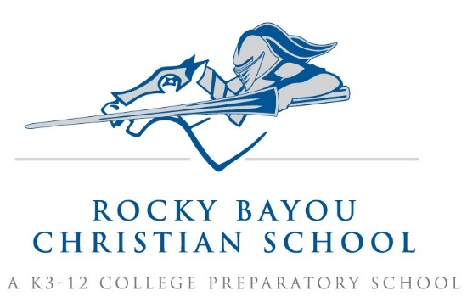

Crestview K5 Grade Supply List AY25/26

- Plastic forks
- 2 large canisters of disinfecting wipes Wipes
- Playdough, 3 ct, any color
- 2 large Elmer’s purple glue sticks
- 2 boxes Crayola crayons, 24 ct
- 3 boxes of Crayola Twistable colored pencils, 12 count
- 3 boxes of classic color washable CRAYOLA markers, 10 count (1 for art, 2 for classroom)
- 1 Crayola 16 ct watercolor paint set
- 1 pkg thin tip black dry erase markers
- 2 pink erasers
- 1 pkg of baby wipes
- 2 boxes of Kleenex- large
- 2 wooden craft 6 x 4 inch picture frames (from Michaels or Dollar Tree)
- 1 pair over the ear, plug in headphones, (to be kept at school) no ear buds
- 1 labeled water bottle with twist off lid that can be refilled independently (non-sweating)
- 1 standard size backpack WITHOUT WHEELS that can fit a folder and lunch box in main compartment
- Lunchbox with handle that can fit inside a back pack
- 1 change of clothes in a large Ziploc bag labeled with your child’s name.

- Girls only- 1 pkg standard size (2.9’), brown wooden clothespins

- Boys only- 1 package of white, uncoated paper plates (for crafts – not eating)

(Please put your child’s name on: change of clothes, water bottle, headphones, backpack, and lunchbox.)

